UNIMASTER

Easy access to European Masters

Alejandro de la Cruz López, Université Paris-Saclay,   
[acrulopez@gmail.com](mailto:acrulopez@gmail.com)

Alessandro Atanassov, Politecnico di Milano, [alessandro.atanassov@mail.polimi.it](mailto:alessandro.atanassov@mail.polimi.it)

Oana-Andreea Butaru, KTH Royal Institute of Technology, [oanabutaru98@gmail.com](mailto:oanabutaru98@gmail.com)

Samuele Gandini, University of Trento,   
[samgandini98@me.com](mailto:samgandini98@me.com)

Taylor Lucero, University Cote d’Azur,   
[telucero@gmail.com](mailto:telucero@gmail.com)

Remy Demolinis, Université de Rennes 1,   
[remydemolinis@gmail.com](mailto:remydemolinis@gmail.com)

EIT Digital Summer School I&E students project report

Cybersecurity for Blockchain, Bratislava

15-26 August 2022

Table of contents:

**1.** **Executive summary (1 p.) 2**

**2.** **Problem and solution (1 p.) 2**

**3.** **Business modeling and planning (2 p.) 2**

3.1 Business modeling 2

3.2 Business planning 3

**4.** **Business development process (2 p.) 3**

**5.** **Self evaluation 4**

**6.** **References, web links 4**

# Executive summary

The purpose of this paper is to explain the development of the idea carried out during the EIT Summer School in Bratislava.

The worldwide education system suffers from issues that in today’s digitalized world can possibly be solved using new and secure technologies. Complex bureaucratic processes, non-existent transparency over processes, amount of time, money and human resources invested, non-existent possibility of taking courses without being enrolled in a degree program - all these are education related problems that immediately come to mind.

We chose to focus on searching for a straightforward answer to the complex administrative problems that universities are facing, specifically considering the challenges associated with the lengthy and expensive university admissions and enrollment procedures. Additionally, we also focused on students, as it is very challenging for them to follow the complete review procedure. Despite the fact that the majority of students and the administrative staff at the university in Bratislava validated the problem, we were unable to proceed along this track because of obstacles associated with validation through other universities. As a result, we moved on to a significant issue for a particular group of people: **American students**. We were able to validate the issue with the help of one of our team members who is from the US and the other five US students we spoke with throughout the summer school.

With the assistance of Balazs Horvath and Ákos Wetters , entrepreneurs and professionals, we were able to realize a more comprehensive and solid solution: **UniMaster** - a unified platform for university admission applications, where students can submit their documents only once and apply to as many programs as they like, and where universities can reach out to students and inform them about their study offer.

The report presents the following insights:

* **Problem and Solution**: a description of the problems that UniMaster is attempting to resolve and the steps it is taking to do so;
* **Business Modeling and Planning**: a detailed description of the business model, go-to market strategy, together with a competitor analysis;
* **Business Development Process**: a review of the decisions the team made during the summer school and how they affected the final product;
* **Self Evaluation**: personal review and evaluation of each of the team members.

# Problem and solution

Focusing on the topic of education, we have identified multiple problems concerning both students and Universities, targeting the University admission process and the cumbersome sub-processes that soon-to-be students are facing.

First, when applying for a University program, students have to submit official documents numerous times, for each University’s application website, since there is no centralized platform that allows one application for multiple programs or universities. Second, the validation of the documents takes a long time, because they are manually checked by admission officers, making the waiting time for a positive or negative result longer. Furthermore, in the process of verifying the documents submitted by applicants, some universities are not verifying the authenticity of the documents provided, admitting and enrolling students with fake certifications. Annually, around 200 000 fake degrees are awarded around the world [1] and enrolling a student with fake credentials produces financial and reputational damage for a University. Another pressing issue is the non-existent transparency of the admission process. Universities often just accept or reject an applicant, without offering any feedback or reason in case of a rejection. Moreover, we have identified universities which do not receive more applicants than the available seats, so at the end of the admission period, there are unfilled seats for some programs, while at the same time, students who got rejected from their first choice program are left on the outside, since they are unaware of other programs in other universities. These issues illustrate the trouble that prospect students and universities go through during the admission period, showing that there is room for improvement for students and also for the institutions.

UniMaster is a platform aiming to solve some of these problems. Students can create their own profile, uploading, only once during registration, the previous diplomas and proof of their identity, to set up a basic profile. Upon registration, the authenticity of the documents is verified, allowing the student to create a profile only if the documents are valid, reducing the fake diploma fraud. Universities partnering with UniMaster publish their study offers on the platform and students choose which programs to apply to. Students only need to upload the original documents and UniMaster takes care of the notarization, possible translation and payments. Regular updates will be accessible in real time on the platform, as well as the visualization of the documents that did not meet the requirements.

An important aspect of UniMaster is the possibility of universities to contact students as well. So far, universities are considered to be untouchable abstract institutions that hardly communicate with students. UniMaster is aiming at balancing the relationship between students and universities. There are a number of universities receiving a lot of applications every year, but there are also universities that do not have that many applicants. For these small, not very visible universities, UniMaster provides the possibility of reaching out to students on the platform, presenting their educational offer, increasing their visibility.

Therefore, UniMaster is a unified solution for students and universities, saving time, bureaucratic paperwork, increasing the visibility of small universities and promoting all countries in the European Union, while at the same time ensuring security and authenticity of vital data and transparency.

# Business modeling and planning

## Business modeling

Our long term plan is clear - we aim to become the ‘de-facto’ solution to manage the application and selection process for students and universities, unifying and simplifying it in all its steps. Figure 1 represents the value network shared between students, universities, UniMaster, governments and the European Union.

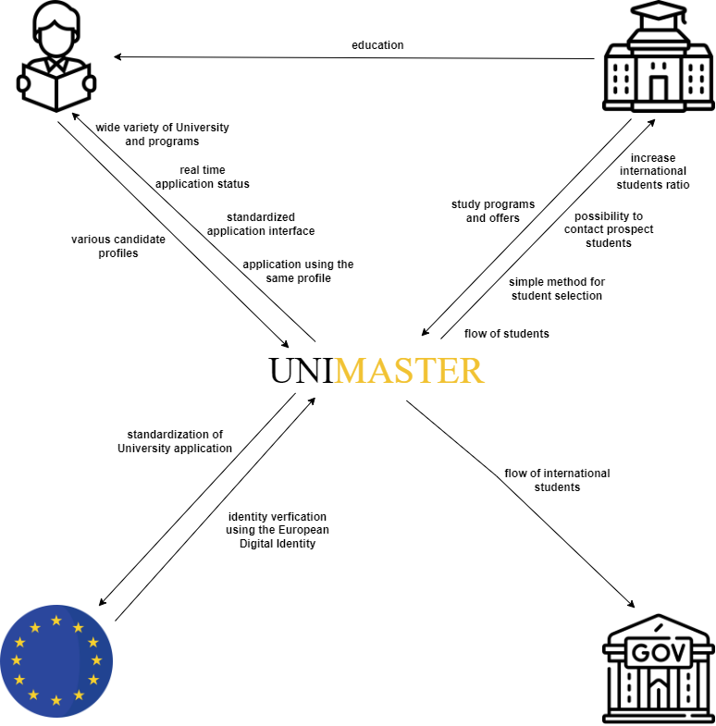

Figure 1 - UniMaster value network

However, in order to start, we plan to focus on a niche from which we can highly profit in order to survive and reach this vision. These would be the American students who want to study in European universities.

Our choice is due to the large number of students going abroad to study in a different country. Indeed, in 2019, 347,099 students left America to pursue their studies elsewhere [2]. Not only is this number steadily increasing year after year (not taking into account pandemic years), but also Europe is their main destination. Around 57.9% of Americans studying abroad are in Europe [2], a proportion that has also been increasing in the last few years.

Spain, Italy, and France are the leading destinations for American students coming to Europe. For this reason, in our first year, we will partner with universities from these countries. Having a subset of countries will also make it easier for us to unify and automatize as many processes as possible.

We have identified the three main tasks that Americans have to deal with in order to apply to a European university. Those are the notarization of degrees and transcripts, which will certify the authenticity of the documents; translation of those documents, since some countries request the documents in their official language; and conversion of grades, due to the different grading scales used in the United States.

We plan to take care of all these processes, including the payments, so that the students have no work to do, aside from selecting the studies they want to enroll in. The students will apply, pay the corresponding fees, submit the documents and wait for the acceptance or rejection from the chosen university.

We will outsource those processes to third parties with which we will negotiate to obtain better pricing due to a higher volume of requests. We are aware that acquiring partners in this field is also key in order to increase our margins.

In our business, we identify the students and our partner universities as stakeholders. Since these two actors benefit from our solution, we plan to charge them both, yet in a different manner. Students will be charged a flat fee of 300€ in order for them to apply to as many universities as they want. If universities require application fees in order to apply for a degree, the student would need to pay them at the moment of the application. There will also be a success fee of 300€ that students will pay if, after being accepted by a university, they want to enroll in it. On the other hand, we will not charge universities at the beginning, since making partnerships with them is a very complex process. After we have proved ourselves useful and trustworthy, we will start charging them. The pricing strategy for universities is not yet decided since it’s a medium-term task, and it’s likely to change due to further research. However, some of the proposed ideas include a yearly flat fee and a fee per student enrolled in the university from our platform.

We have identified three main competitors to our solution. Those are Cappex, UCAS, and Common App. What differentiates us from them is that we take care of all the bureaucracy and legal processes regarding their application documents. Our aim is to make the application process as easy as submitting the raw documents, which no other competitor does. Another feature that only UCAS includes is the ability for universities to directly contact students.

The implications of our solution on a societal level are several. The unification of the application process will allow students to study freely around the globe wherever they want with little to no friction. This will increase competition between universities for the best students and, therefore, improve the education given to students. Furthermore, simplification will highly reduce universities' costs of managing, processing, and authenticating documents. This will allow universities to use this recently freed money on providing a better experience for the student. Our solution provides another step into a globalized world where the country you were born in becomes a characteristic rather than your fate.

## Business planning

Regarding the financial part, we started by calculate our fees, firstly the marketing including the advertising through social media with ads or influencers, which will be our biggest part of the expense and the scholarships that we will offer to the best accepted students on our platform: 100,000€/year; Secondly the cost of our infrastructure: 2,000€/year; And thirdly our salaries at the beginning 120,000€/year which correspond to about 1,667€/person/month.

With those expenses, as we said in the previous part, we chose to charge the student a flat fee of 300€, in those 300€ we have to pay 250€ for the translation and notarization of all the documents, so we only make 50€ on that fee. And for the accepted ones a success fee of 300€ too. So, according to the plannings of applications and acceptances, our revenue will be seasonal between March and July each year.

According all those information here is the curve of the cash flow of UniMaster for the first three years of activity of the platform (so after the development and everything before):

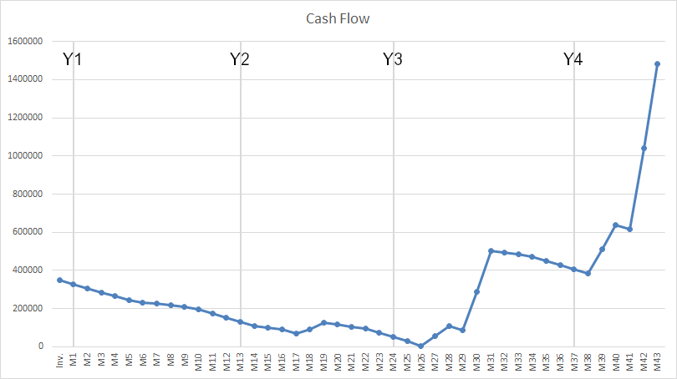

So, we decided to ask for 350,000€ for investments, and we will reach the “break even” around the month 29/30 which is March/April 2025.

For this scenario we assumed that the first year we can have 120 students which represent 0.57% of the U.S. students in Master's who come to study in Europe. And for the second year we multiplied this number by 5, so 600 students, and the same calculation for the third year, so 3,000 students.

# Business development process

After identifying the conceptual problem that we decided to work on - the difficulties encountered by both students and Universities during the application process -, we started the validation process by interviewing the EIT representatives working at the STU.

### 

[Viltaré Platzner](https://www.linkedin.com/in/viltar%C4%97-platzner-b47484127/)

[Peter Cuninka](https://www.linkedin.com/in/peter-cuninka-71b0a7a0/?lipi=urn%3Ali%3Apage%3Ad_flagship3_profile_view_base%3Bzka6OR4TQnOCO58l2awDPA%3D%3D)

[Štefan Hičák](https://www.linkedin.com/in/%C5%A1tefan-hi%C4%8D%C3%A1k-42b84419/?lipi=urn%3Ali%3Apage%3Ad_flagship3_profile_view_base%3BFW1u6IVuRf%2B8KvSBvHgy0g%3D%3D)

**[(Program Coordinators)](https://www.linkedin.com/in/%C5%A1tefan-hi%C4%8D%C3%A1k-42b84419/?lipi=urn%3Ali%3Apage%3Ad_flagship3_profile_view_base%3BFW1u6IVuRf%2B8KvSBvHgy0g%3D%3D)**

We Interviewed them on the admissions and enrollment at the STU in Bratislava. They helped us to invalidate our original and provided resources to help guide us to our current solution.

[Balazs Horvath](https://www.linkedin.com/in/balazsfromkimitisik/?lipi=urn%3Ali%3Apage%3Ad_flagship3_profile_view_base%3Bzka6OR4TQnOCO58l2awDPA%3D%3D) 

(Entrepreneurship coach)

Provided feedback and coaching on where we needed to improve, and helped direct us in the appropriate direction.

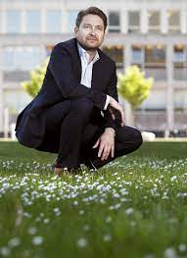

[Akos Wetters](https://www.linkedin.com/in/akoswetters/?lipi=urn%3Ali%3Apage%3Ad_flagship3_profile_view_base%3Bzka6OR4TQnOCO58l2awDPA%3D%3D)

(Entrepreneurship coach)

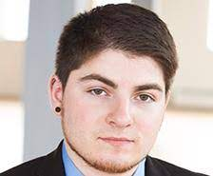

[Taylor Lucero](http://www.linkedin.com/in/taylorlucero1)

(Key to validation)

Provided first hand experience on the application process for American students coming to the EU

Our particular process when determining best actions and hypotheses to test, began with asking the coordinators about the ins and outs of STU’s admission and enrollment processes. However, we had to pivot because our initial validation of the problem failed, since we could not expand to other universities. Soon after, we began focusing on American students due to the difficult application and admission process our American teammate experienced. From him, we were able to gather first during the process, we also researched other stories and experiences about Americans coming to Europe for higher education. To collect even more data we asked various questions to Americans already studying in Europe, avoiding questions that would ruin our analysis due to bias. Soon after, we were able to support our solution to the problem with hard statistics showing an increase in American students coming to Europe for cheaper higher education and a larger diversification of cultural skills that the US does not supply.

With our validation of the problem, we developed an appropriate solution that simplified the process for Americans wanting to study abroad. Our platform would act as an intermediary between students and universities with appropriate and relevant open study positions. Students would use our platform to apply and submit the necessary documents needed for the applied program. These documents, generally, consist of transcripts, birth certificates, and diplomas.

We have identified the three main tasks that Americans have to deal with in order to apply to a European university. Those are the notarization of degrees and transcripts, which will certify the authenticity of the documents; translation of those documents, since some countries request the documents in their official language; and conversion of grades, due to the different standards used in the United States.

We plan to take care of all these processes, including the payments, so that the students have no work to do except selecting the studies they want to enroll in. The students will apply, pay the corresponding fees, submit the documents and wait for the acceptance or rejection from the chosen university.

We will outsource those processes to third parties with which we will negotiate to obtain better pricing due to a higher volume of requests. We are aware that acquiring partners in this field is also key in order to increase our margins.

Between our stakeholders, we identify the students and our partner universities. Since these two actors benefit from our solution, we plan to charge them both, yet in a different manner. Students will be charged a flat fee of 300€ in order for them to apply to as many universities as they want. If universities require application fees in order to apply for a degree, the student will need to pay them at the moment of the application.

During the program we approached conflicts and issues with a more democratic style, by voting or looking at the most popular opinion the members of our team had. There were of course some issues in regards to ideology and supporting explanations on differing opinions. Generally, we completed in a divide and conquer style, where we would split up and complete various tasks. If an issue arose, we tended to write out possible paths to the solution from the problem.

Looking ahead, we hope to begin communicating with the universities in the three countries most targeted by American students, France, Spain, and Italy. While working on solidifying the network of universities in these countries, we will be working in parallel on the technical aspects like web development, UX design, and data warehousing information and the non-technical aspects supporting notarization and translation of student documents.

Once a working platform has been developed and has solid backing from France, Italy and Spain, the universities will then supply available positions to us while the students will apply to these universities on our platform. By making the application process efficient for the student when applying and removing the need to find notaries and translators for documents it will ease the process of international students coming to Europe.

At the end, after we have proven to be valuable for our stakeholders, we are planning to expand our business, following a series of steps. From the side of the universities, we will start a campaign to gather even more European universities to our network, not only within the same three aforementioned countries, but more in general to any country in the European continent. From the perspective of the students, we have two directions of growth: one is by type of course, and we are planning to open the platform for Bachelor’s degrees as well; the other is by origin continent, in which we would start a campaign for students from new continents other than America - starting from Asia, another continent in which many students migrate to the EU to study.

# Self evaluation (1 p. per person)

Each team member has to write a short reflection (1 page each):

* Team organization, roles and process
* Your own contribution to the project
* Learning experience: what did you learn? (content, applicability of methods and tools, process)
* What did you miss with respect to your own competences?

## Alejandro de la Cruz López

Team organization was difficult at the beginning. We didn’t know which skills each one had and lacked. For this reason, in the beginning, for each activity we needed to accomplish, we brainstormed a proper division of the task and then went through each of them finding volunteers to make it. After some days, the process became smoother and we started knowing each other better. From that moment on, we found the role that each person best fits in.

Samuele became the jack of all trades, he could accomplish any task regarding design, research, or ideation; he became the go-to person for any sudden urgent task that emerged. Remy took the task of researching, validating, and working on everything related to the financial part; he worked on finding different business and pricing models to create a healthy business with minimum risk. Alessandro did in-depth research on the competitors and also became a very valuable member from whom you could ask for sincere feedback and solutions to any incoming problem. Taylor led the research on the American market due to his valuable experience as an American himself that came to Europe to study. He helped everyone by providing meaningful feedback on the provided context while executing his own tasks successfully. Oana provided guidance on the worst moments, after each destructive feedback from the mentors, she stepped in looking for solutions and reunited the whole team together not to give up on our shared vision. I took care of organizing the tasks and thinking about the next step to be done for the project, thinking about the skills of each team member in order to distribute them fairly and effectively. I also became the pitcher anytime we needed one such as on the first day’s contest to obtain the ‘education’ theme and the 5-minute last pitch.

This summer school helped me improve greatly on several fundamental skills. First of all, I put into practice the skills of organizing a team and take into consideration all team members' opinions and drives. A team is formed of very different people with different personalities and aspirations. In order to get the best performance of each member and teamwork is crucially important to take all that information into consideration. I find incredibly valuable the real-life experience the summer school provided me in that matter.

The second takeaway I will highlight is the importance of being down-to-earth when it comes to developing a business idea. Our team kept talking about the vision and where we wanted to be in several years, but we barely discussed how we could get to that point. It took us several mentor discussions in order to realize this matter. Creating a business is not smooth sailing, it requires being aware of the fact that you cannot do everything you want to. Choosing a niche and developing a plan for the beginning is essential, and can differ a lot from the initial vision.

Last but not least, I practiced getting myself out of my comfort zone during the summer school. From overcoming the fear of public speaking to improving vital soft skills, I did my best to get the most out of the experience, which I did. That makes this summer school another important milestone in my growth as a professional, and as a person.

## Oana-Andreea Butaru

Organizing the team during the first tasks was difficult since we had just met each other and we were unaware of each other’s strengths or weaknesses. Therefore, we tried to divide the tasks and ask what tasks are preferred by each team member. After the first few days, some strengths and weaknesses were clear for all the members of the team. Alejandro was always ready to step in and take new initiatives, asking the right questions after someone came up with a new solution, proving critical thinking and good managerial skills. Samuele was deeply involved in all the processes, from ideation, to research, to design, providing help and always ready to accomplish any type of task. Taylor was the key member with regards to the research and validation of American students coming to Europe, offering information about his own experience. Remy accomplished valuable work on the financial side of the project, looking for the most suitable business model for UniMaster. Alessandro did research on the competitors, helping with honest feedback along the way. I was responsible for the initial validation and for pivoting after receiving feedback from the coaches and for trying to find middle ground between 6 visions that existed within the team and 2 more visions expressed by the coaches, so that everyone could feel included and happy to work on the project.

This experience has definitely helped me improve some skills, such as teamwork. Since we did not know each other from before, it took a bit of time in the beginning to assess each other’s skills. I learned how difficult it can be to work with five people you just met. The biggest takeaway, in my opinion, is developing patience, practicing again how to listen to everyone’s opinion and ideas, how to encourage others to talk and to express their point of view. Furthermore, the feedback we got from the coaches was valuable, as I was able to learn the processes that you can go through in order to make the project better, to come up with better and unexpected ideas. I learned ways of making your idea stand out. Most importantly, I learned that good ideas are founded on real life problems, and for that, validation is mandatory. Regarding validation, I learned that it is a very time consuming process and for that you need a wide network to ask the proper questions in order to find out their pain points. Another important aspect was working on the pilot, not jumping straight to the conceptual project. It took us multiple iterations to define the pilot, since we had so many conceptual ideas that we wanted to integrate. I learned that starting from a niche target group is more important than introducing all features to a project from the very beginning.

To summarize, I believe that the summer school experience helped me a lot in improving my soft skills, my teamwork skills, stepping out of my comfort zone, and working on an interesting topic with a very diverse team. Personally, I am happy with the work we have done and I believe our idea has great potential for the future.

## Taylor Lucero

At the beginning building a solid between six individuals from varying backgrounds, who had never met each other was difficult. We were a bit unsure of ourselves and even more unsure of how our skills and personalities would mesh further into our project. Later on though, after intensive networking and constantly, we built distinctive relationships between one another. This helped ease us into the second week of further defining the inception of UniMaster. Once we began to feel more comfortable with each other we found our distinctive roles that helped benefit the group.

Alejandro was a key figure when moving in a new direction. He would help the group organize our thoughts and identify aspects we should focus on. Oana was another individual who frequently led the charge. She had a dynamic role that went from intensive ideating to helping Samuele research competitors. Samuele was a jack of all trades, he did intensive research on our competitors and also played a major role in our design. He was always calm and ready to help when needed. Rémy covered more of the technical problems. He looked at the bigger picture when handling our financials that helped guide our road map and make realistic expectations on the amount we ask investors.

This experience helped me cultivate new skills like teamwork that was difficult to develop in my first year at university. So far most projects I have worked focused on a two person dynamic, while this project had use working with six different individuals. The tactics in working with a two person group slightly differ from a six person group as the amount of time we were allotted was limited. Thankfully, the feedback from our coaches helped to push us forward in the right direction. We still faced some arguments and differences of opinion but being able to work those out and move was part of the learning process.

Overall, I believe this was a very fruitful endeavor. I managed to communicate and network with individuals I normally would have never met, while also working towards pitching to investors.Not only did I learn many soft skills that complement the technical skills this program focuses on, but was able to apply those in action.

## Alessandro Atanassov

I still remember the day of our first team working session. We were all worried because everybody was claiming not to be the “creative” person that every team would desire; instead, our common ground was that we all are analytical people, which was actually a point of strength, because everybody needs some critical thinking to make an idea a reality.

Our second hurdle was finding a way to connect innovativeness with feasibility, especially given the short amount of time available. Validating an idea in less than two weeks is not trivial, especially in August, since one of our main targets were the universities. This contributed to our repeated pivoting of our base idea, to become what we proposed at the end.

Lastly, another constraint to our ideation phase was finding a suitable business model, which would allow us to scale up and become profitable in the long term.

Despite all of this, we persevered, and managed to come up with an innovative solution that tackled a real problem, with a well balanced business model. Towards the end, we caught up and made considerable progress, which was rewarded by our coaches with positive feedback.

Regarding my personal contributions to the final output of our teamwork, I decided to let the others explore, validate and build plans around new ideas, while I ensured that our solution was actually new to the market, thanks to the competitor analysis that I performed. Another important contribution of mine was to solve the problem of convincing both parties (students and universities) to use our platform, by proposing both the scholarship model and - also thanks to Balazs’s suggestion - the success fee. Lastly, partly due to my limited improvising skills, I always preferred to plan our pitches in advance, by writing the scripts for the team; not only were they useful for me, but I hope they were also an inspiration for my teammates’ pitches.

This summer school was a challenge for me, because for once I also saw what my limits are. I was used to the usual technical projects, in which I have a set of specifications, and I create software out of it. In this type of project instead, you have to take a step back, and ideate your own concept and specifications. Another challenge is that you have to put in practice the knowledge you gathered in I&E courses during the entry year, by creating a concrete business plan; you soon realize that only knowing the meaning of Marketing Mix, Business Model, Pilot and others is not enough, if you do not know how to apply them to something real. I also felt like the rest of the team had similar uncertainties as mine, especially at the beginning, but eventually we made it through.

To conclude, what I appreciated the most of the summer school is the emphasis on the concept of “Networking”. Since then, I tried to approach and hold a conversation with as many people as I could, and even if it was often just “small talk”, it was still better than my usual silence. This contributed to the development of my social skills, which I believe to be my biggest learning outcome: not only is it part of my personal growth, but being a good communicator is crucial for an entrepreneur. Also, thanks to the awareness spread about networking, I felt like my EIT colleagues also tried to follow the advice, by being open to new connections, and being warm with everyone.

## Samuele Gandini

Since nobody knew everyone at first, it was really challenging to determine the right role for each component. But after a few days, we learned how to collaborate effectively, concentrating on the growth of the idea and on our strongest characteristics to make the most of the short time at disposal.

Alejandro made an effort to lead the entire team by delegating tasks and providing the project with the right direction. He was also the pitchman, successfully winning over one of the judges' hearts during the final pitch. Oana was essential in getting the team organized and in coming up with a solution after the mentors destroyed our new ideas. Taylor and Rémy thoroughly researched the market and validated our final model. They concentrated on the financial component and the potential for making it concrete. Alessandro contributed to the improvement of the quality and feasibility of the idea through his research on the competitors and his attempts to disprove every suggestion. It was helpful to identify the main weaknesses and any shortcomings. For example, he suggested introducing scholarships for American students.

With the team's assistance, I feel that I have enhanced my design abilities, creating very excellent slides as well as a strong narrative. At the beginning of the summer school, I was also really shy, which made it very difficult for me to fit in with the group. After only a few days, I was able to identify my role, and because of this, I believe my organizational and managerial skills have also improved.

Considering my own competences, I failed to identify whether our project also included a Cyber Security component (the main topic of our Summer School in Bratislava). In my defense, given that our project's focus was on administrative concerns for American students coming to Europe, it was practically impossible for me to speak about Cyber Security.

Anyway, I'm sincerely satisfied with my Summer School experience because the idea was well developed and we received positive feedback from the judges for our efforts. Furthermore, I was able to expand my network by meeting amazing new people.

## Remy Demolinis

Back to the first day of team building, we were discovering each other and everybody said that creativity was a weakness. So, we identified barely the same strength in programming and the same weakness in creativity. And with the short time that we have to do the project, I thought that it would be difficult to achieve it.

A few days later, when we really started the ideation, we directly had the idea of something in the educational field, to help students, because nowadays they are the people who need help. So, at the beginning we were thinking about something with blockchain and everything in correlation with the topic of the summer school.

But after a lot of problem during the ideation, the impossibility to face some and the idea to high level, we did two pivots and at the end the cybersecurity part was not here anymore, but for me it was not a problem because I really liked the topic that we chose, and I think I was not the only one, even if I knew that it will be impossible for us to win the contest because of the cyber security part.

So, we had the perfect topic and now we needed to elaborate the rest. Thanks to Alejandro and his managing skills he led us in the right direction, he is also the greatest pitcher of our team. I surely have to speak about Oana because she really was a cornerstone of the team, after the two destructions of our project by the coaches she always found a way to bounce back and reunite the team. After we had Samuele, who was the handyman, he did a lot of research, made the theme of the slides, and if we needed someone on something he was always volunteering to do some tasks. Like we said before Taylor was the key to validation, he told us his story as an U.S. student who came to study in Europe, and the project was born. He also did a lot of research as all of us, but more in the student processes. Alessandro was the one who identified our competitors and looked for how we could be better than them. And for myself I did the financial part of the project and checked barely everything to know how we can be profitable, without too many problems.

To conclude, I am very proud of us for this project I think we really had a good team, and I really liked the topic, even if we didn’t win because of the cyber security part, according to the jury our business model and field was the best, and for people who claimed not to be creative, I think we all improved our creativity, thanks to the team working.

If I have anything else to add, it would be a real acknowledgement to all members of the team for that and to the coaches too who really guided us in this project.

# References, web links

[1] <https://employerschoicescreening.com/news/other-articles/5-scary-statistics-damaging-diploma-mills/#:~:text=Roughly%20200%2C000%20bogus%20degrees%20are,lifetime%2C%20second%20to%20their%20home>

[2]

<https://www.nafsa.org/policy-and-advocacy/policy-resources/trends-us-study-abroad>

<https://www.collegexpress.com/articles-and-advice/admission/articles/college-applications/comparison-most-popular-college-application-platforms/>

<https://www.ucas.com/about-us/who-we-are>

**End of document**